

THE HERITAGE

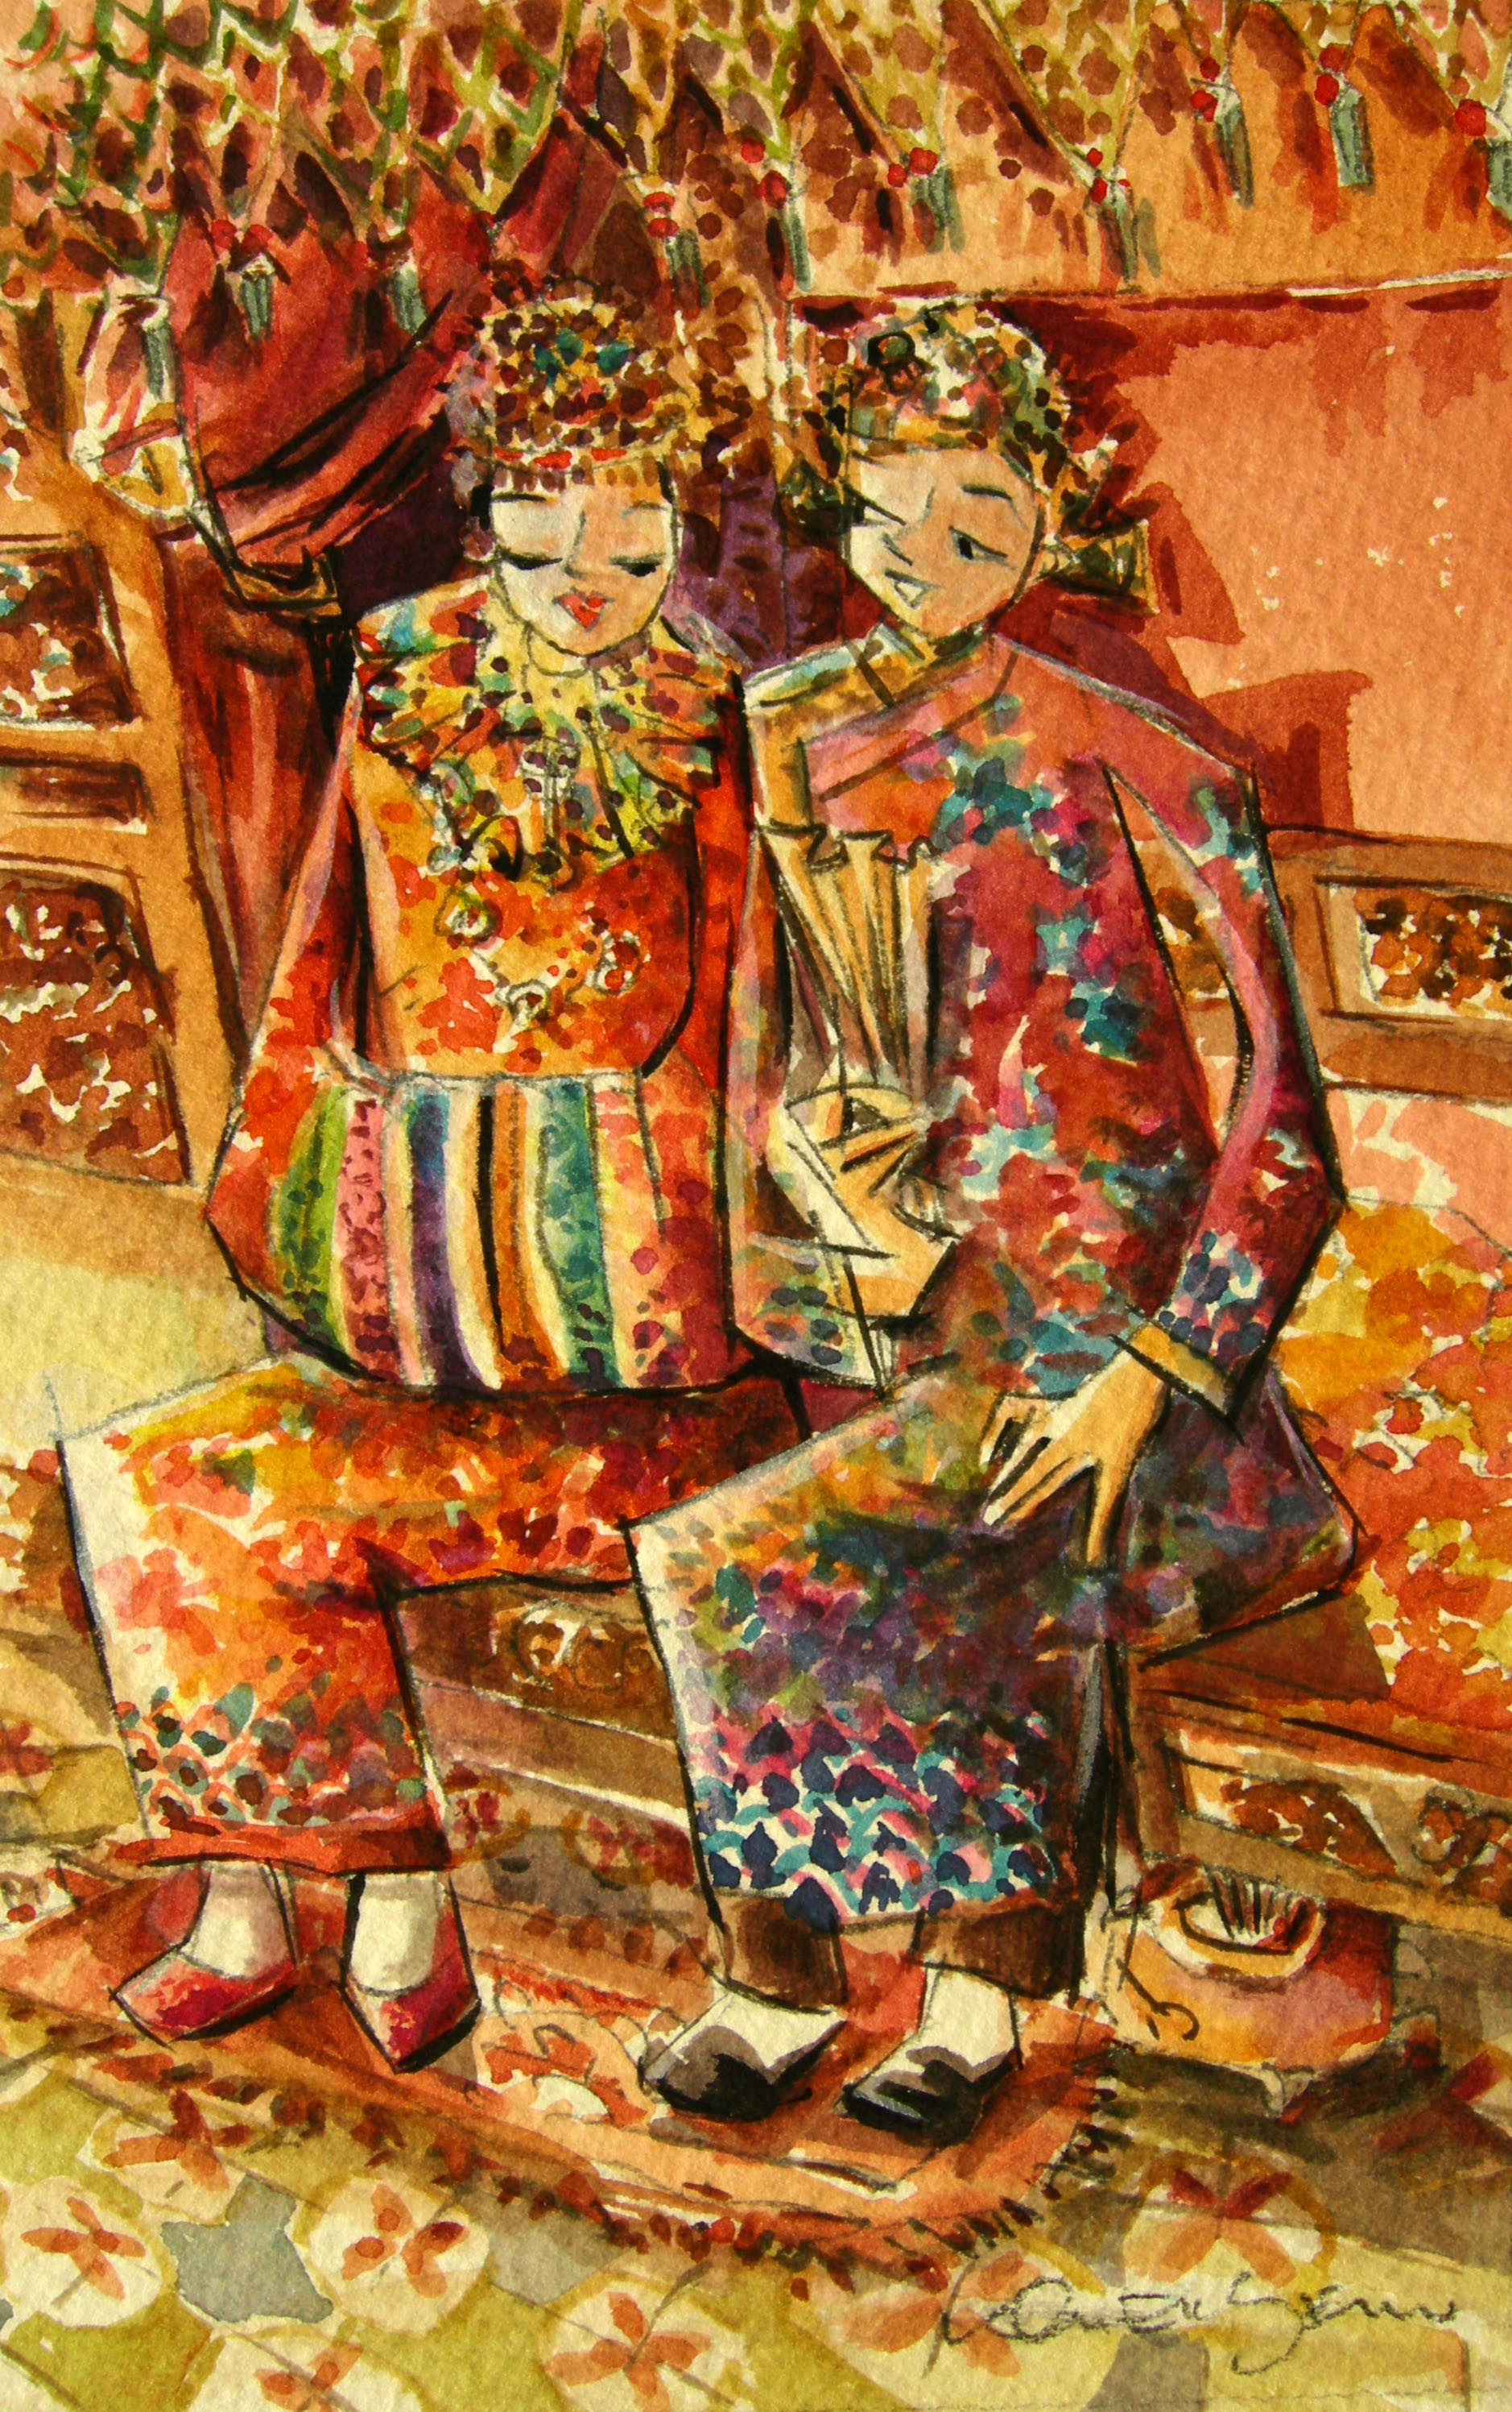
The Bridal Chamber
The bridal chamber is in the bride’s home. It should be fully and appropriately furnished with new curtains, embroidered tapestries, carpets and flowers. A comb of pisang raja, serai and yam, together with three lit joss sticks are placed in an earthenware pot beneath the bed. These symbolise wealth, longevity and fertility, and convey good wishes to the bride and groom. The room is filled with fragrance of bunga rampai, a fresh scent derived from pandanus leaves, flowers and stanggee. (Stanggee is a local incense made fom various roots and bark, sugar cane and sugar.)

